What are the types of membership functions in fuzzy logic?
- Fuzzy membership functions are defined as mathematical functions that quantify the degree of membership of an element in a fuzzy set, with common types including impulsive, triangular, trapezoidal (both left and right sided), and Gaussian functions.
- There are different forms of membership functions such as:
Triangular
Trapezoidal
Piecewise linear
Gaussian
Singleton
Sigmoid
Z shaped

What is a fuzzy singleton? (Singleton Membership Function):
- A fuzzy singleton is a fuzzy set with a membership function that is 1 at a single point and 0 everywhere else.
- A fuzzy set is a fuzzy singleton if its support (the set of elements with non-zero membership) is a single point, and the membership value at that point is 1. g

Singleton Membership function / Vertical Line Shaped:
The membership function, μ_{A}(x), for a fuzzy singleton 'A' would be defined as:
μ_{A}(x) = 1 for a single point 𝑥.
μ_{A}(x) = 0 for all other points in the universe.

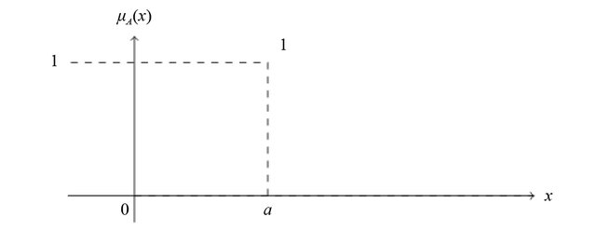

Figure: Singleton membership function

Triangular Membership Function / Λ-type (Triangular Shaped):
- Triangular membership functions are defined by three parameters (a, b, c)
- Have a triangular shape with the peak representing full membership (μ =1).
- Endpoints (a and c) represent no membership (μ = 0).
- The membership function, denoted by μ_{A}(x), is defined piecewise:
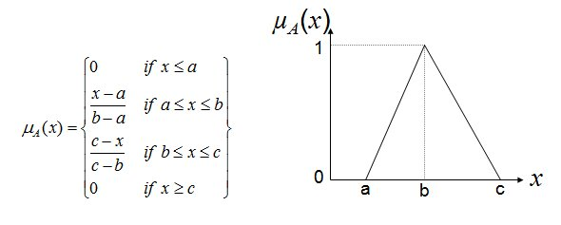

Figure: Triangular membership function

Trapezoidal Membership Function / Π-type (Trapezoidal Shaped):
- Trapezoidal membership functions are defined by four parameters (a, b, c, d)
- Have a trapezoidal shape with a flat top representing full membership (μ = 1).
- Endpoints (a and d) represent no membership (μ = 0).
- The membership function denoted as μ_{A}(x) is defined as:

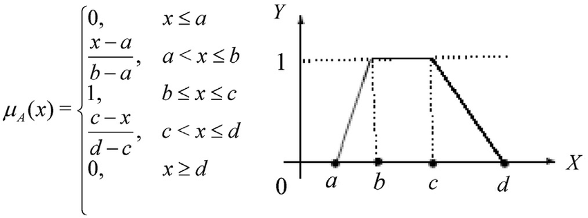

Figure: Trapezoidal membership function

Gaussian Membership Function / Bell shaped:
Gaussian membership functions are defined by two parameters (mean and standard deviation)
  - Have a bell-shaped curve with the mean representing the center of the function
  - Standard deviation controls the width and spread of the function

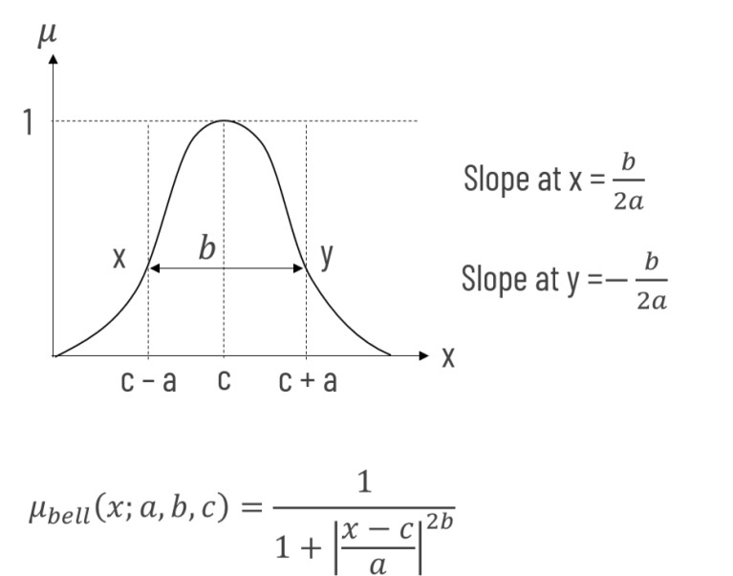
- It is defined by the equation:

- Mean (𝑐): The center of the function, where the membership value is 1.
- Standard Deviation (𝜎): Controls the width of the curve. A smaller 𝜎 results in a narrower curve, while a larger 𝜎 results in a wider curve.

Sigmoid Membership Function / Wave shaped / S-Shaped:
Sigmoid membership functions are defined by two parameters (a and c)
  - Have an S-shaped curve transitioning smoothly from no membership (μ = 0) to full membership (μ = 1)
  - Parameter 'a' controls the steepness of the curve, 'c' determines the midpoint

A sigmoid membership function in fuzzy logic is an S-shaped curve that represents gradual transitions in membership from 0 to 1. It is defined by two parameters: 𝑐, the point of inflection (where the curve crosses 0.5), and 𝑎, which controls the slope and width of the transition area.
- It is defined by the equation:
$μ_{A}\left(x\right)=\frac{1}{1+e^{-a(x-c)}}$
- 𝑐: This parameter is the center of the function, or the point of inflection where the membership value is 0.5.
- a: This parameter determines the slope of the curve. A larger magnitude of 𝑎 results in a steeper slope and a narrower transition area, while a smaller magnitude results in a gentler slope and a wider transition area.

The sign of the parameter 𝑎 determines whether the curve increases or decreases.
- If 𝑎 is positive, the curve increases from left to right (from 0 to 1).
- If 𝑎 is negative, the curve decreases from left to right (from 1 to 0). This is sometimes referred to as a generalized sigmoid function, and its opposite is the "difference" sigmoid, which is a difference of two sigmoids.

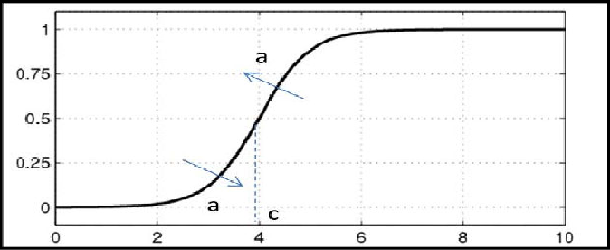

Figure: Sigmoid Membership Function

Piecewise Linear Membership Function:
- A piecewise linear (PL) membership function is a function in fuzzy logic that is defined by a series of connected straight line segments.
- A PL membership function is linear over finite intervals.
- This type of function is used because it can be computationally simpler than non-linear functions.
- Examples include triangular and trapezoidal membership functions.
- The key to building a PL membership function is determining the appropriate "reference points" that define the slope and position of each line segment.
- Constructing a PL membership function:
The most critical step is identifying the correct reference points (also called "knots") where the slope of the function changes.
Once these points are defined, the function is constructed by connecting these points with straight lines.

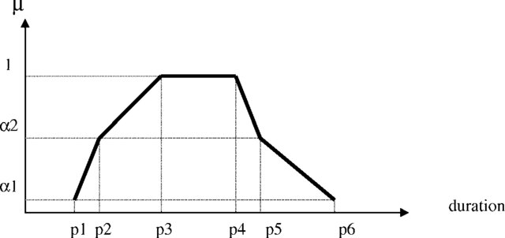

Figure: The 6-point piecewise linear membership function.

Z membership function:
A Z membership function is a fuzzy set membership function that takes a Z-shape, defined by a lower bound 𝑎 and an upper bound 𝑏. It represents a value's membership grade, which is 1 for inputs less than or equal to 𝑎, decreases linearly between 𝑎 and (a+b)/2 and is 0 for inputs greater than or equal to 𝑏.

Parameters:
It is defined by two parameters, 𝑎 and 𝑏 where 𝑎 is the "foot" and 𝑏 is the "shoulder" of the function.
a: The point where the membership value starts to decrease from 1.
b: The point where the membership value reaches 0.
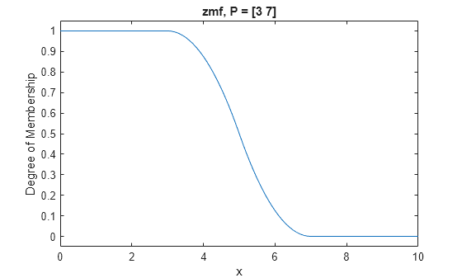

Figure: Z membership function where a=3 and b=7.

The membership function is defined by the equation:

For a linear Z-shaped function, the equation is:

Differentiate between fuzzy and probability citing an example.
Probability deals with randomness and objective chance, while fuzzy logic handles vagueness and subjective degrees of truth. For example, a probability might state there is a 95% chance of rain tomorrow, but fuzzy logic could describe the same event as having a 0.7 degree of "heaviness" in the rain, which is subjective and doesn't require a single, verifiable outcome.

Probability vs. Fuzzy Logic
Feature | Probability | Fuzzy Logic
Core concept | Randomness, objective chance | Vagueness, subjective "shades of gray"
Underlying principle | Mathematical certainty of a single event or outcome | Degree of membership in a set (e.g., "tall,""warm")
Measurement | Expresses the likelihood of a discrete event occurring | Expresses a continuum of membership from 0 to 1
Application | Predicting an event with a specific likelihood | Defining and working with linguistic terms and concepts

Example: Weather
- Probability:
A meteorologist uses probability to say, "There is an 80% probability of rain tomorrow." This means that in a large number of similar situations, it would rain 80% of the time. The event is a clear "yes" or "no" outcome, but we are assigning a degree of certainty to it.
- Fuzzy Logic:
A weather system could use fuzzy logic to describe the rain itself. It might determine the statement "it will be very rainy" is true to a degree of 0.6. This is not a measure of probability of the rain happening, but a measure of how well the current conditions fit the subjective concept of "very rainy," based on variables like amount of rainfall, wind speed, and cloud cover.

Concept: Fuzzy logic is based on the idea of degrees of truth rather than the traditional binary true/false (0/1) dichotomy. It allows for values between 0 and 1 to represent the truth of a statement.

Concept: Probability measures the likelihood of an event occurring, expressed as a number between 0 and 1, where 0 means the event will not occur and 1 means it will certainly occur.

A fuzzy set is a mathematical concept that generalizes a classical set by allowing elements to have a degree of membership that ranges from 0 to 1. Unlike traditional sets, where an element either fully belongs (1) or does not belong (0), fuzzy sets can represent vagueness and uncertainty, where an element can have a partial or gradual membership. This is useful for modeling concepts like "young person,""hot temperature," or "tall object" where the boundary is not sharp.

Key characteristics

Membership function:
A fuzzy set is defined by a membership function that assigns a value between 0 and 1 to each element, indicating the degree to which it is a member of the set.

Partial membership:
An element can partially belong to a set. For example, a person who is 25 years old might have a membership degree of 0.7 in the fuzzy set of "young people".

Vague concepts:
Fuzzy sets are particularly useful for representing concepts that are imprecise or subjective in natural language, which are not well-handled by classical set theory.

Example
Crisp set:
In the crisp set "people over 18," someone who is 17 is not a member (0), and someone who is 25 is a member (1).

Fuzzy set:

In the fuzzy set "tall people," a person who is 6'0" might have a membership degree of 0.6, a person who is 6'5" might have a membership degree of 0.9, and a person who is 5'10" might have a membership degree of 0.3.

Standard Membership Functions:
